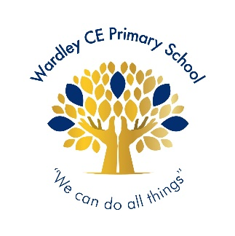**Wardley CE Primary School**

**‘With God’s love we enjoy and excel’**

**Celebration -Shout Out**

|  |  |
| --- | --- |
| **Nursery** | **Arabella** |
| **Reception** | **Rory** |
| **Year 1** | **Omar** |
| **Year 2** | **Roman** |
| **Year 3** | **Alex** |
| **Year 4** | **Mila** |
| **Year 5** | **Amelia** |
| **Year 6** | **Danielle** |



|  |  |
| --- | --- |
| **Year 1** | **Noah** |
| **Year 2** | **Elliott** |
| **Year 3** | **Ollie** |
| **Year 4** | **Anson** |
| **Year 5** | **Sienna** |
| **Year 6** | **Emily** |



**Handwriter of the Week**

|  |
| --- |
| For knowing how to keep calm and deal with difficult situations. |
| Year 1 – Emilia J, Lucas, Reema, Lexi, Rueben, Evelyn, Kavin, Rudi, Anna |
| Year 2 – Anais, Alex, Sienna, Jude, Harlie, Oakley, Mia |
| Year 3 – Jeevan, Eva, Leah, Koby, Olivia, Prescious-Jewel, Olivia, Savannah, Ollie, Alex, Georgie, Mia |
| Year 4 – Lucy, Blake, Poppy, Grace, Darren, Lola, Seth |
| Year 5 – Ellis, Kayal, Alexis, Backett, Yas, Eleanor, Dominic, Megan, Ava E, Kyron, Courtney, Anna |
| Year 6 – Danielle, Charlie, Ben, Phoebe, Joe, Suraya, Charlotte, Emily, Sienna, Ralph, Thea |

**Jigsaw Stars**

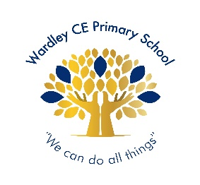

**Wardley Way Awards**

Well done to the following children for achieving their gold award:

**Gold Award**

Well done to the following children for achieving their silver award:

Y5: Mollie Y4: Grace & Arthur

Y3: Letty Y2: Anais & Willow

**Silver Award**

Well done to the following children for achieving their bronze award:

Y5: Dominic, Ellie-Mae, Angus & Finlay

**Bronze Award**

**Headteacher’s Special Awards**

***Year 5: Beckett for his superb writing.***

***Ava for her super science work.***

***Year 4: Rafeef & Freddie T for their wonderful haiku poem.***

***Year 1: Lexi for being such a fantastic pupil in class.***