Monday | 25 + 4 = |  | 3 twos = | Circle the heavier object | ¼ of 16 = .
Tuesday | 31 - 6 = |  | 4 fives = | 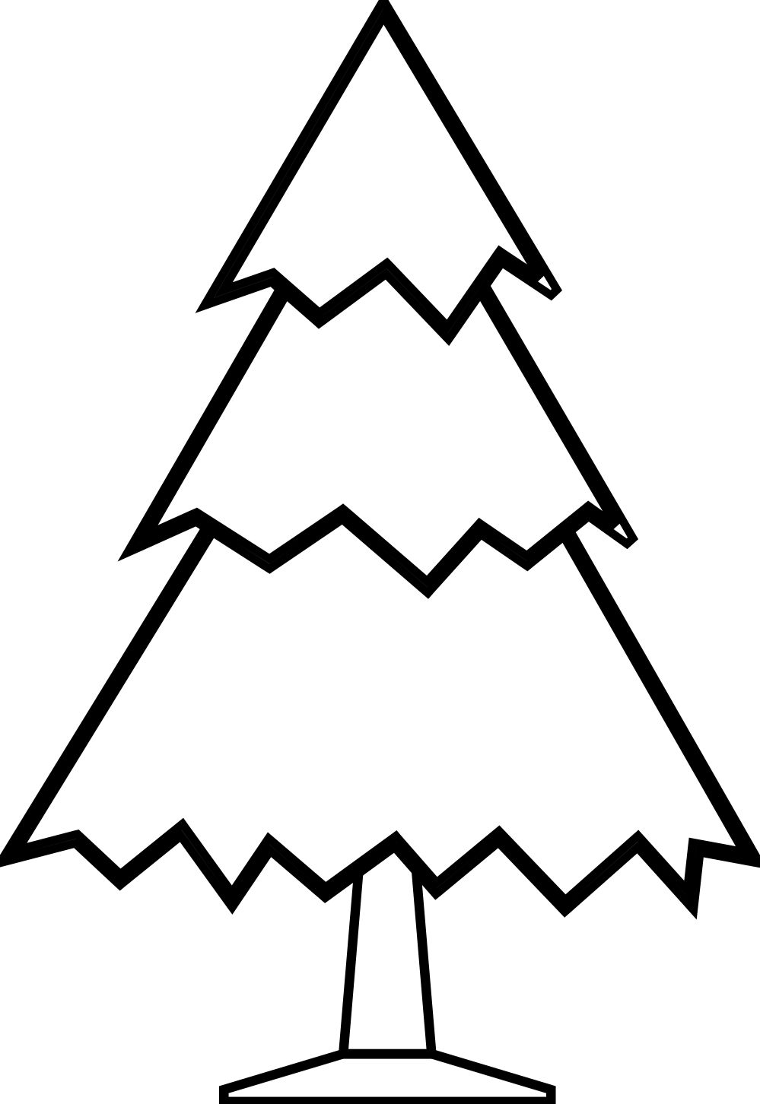  Circle the taller tree | ¼ of 8 = .
Wednesday | 28 + 2 = |  | 3 threes = | Circle the shorter tree | ¼ of 20 = .
Thursday | 20 - 9 = |  | 2 sixes = | Circle the shorter line | ¼ of 12 = .
Friday | 24 + 6 = |  | 3 fours = | Circle the lighter object | ¼ of 4 = .
5 A Day

