Tuesday | 15 - 4 = |  | 5 twos = | 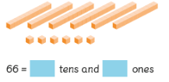 | ½ of 12 = .
Wednesday | 25 + 3 = |  | 3 fours = | 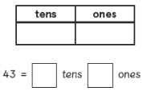 | ¼ of 16 = .
Thursday | 20 - 4 = |  | 2 tens = | 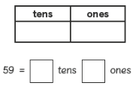 | ½ of 18 = .
Friday | 23 + 7 = |  | 5 fives = | 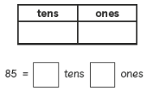 | ¼ of 20 = .
5 A Day

