Monday | quarter of 8 = | 34 | 10 x 2 = | 20 + 9 = | 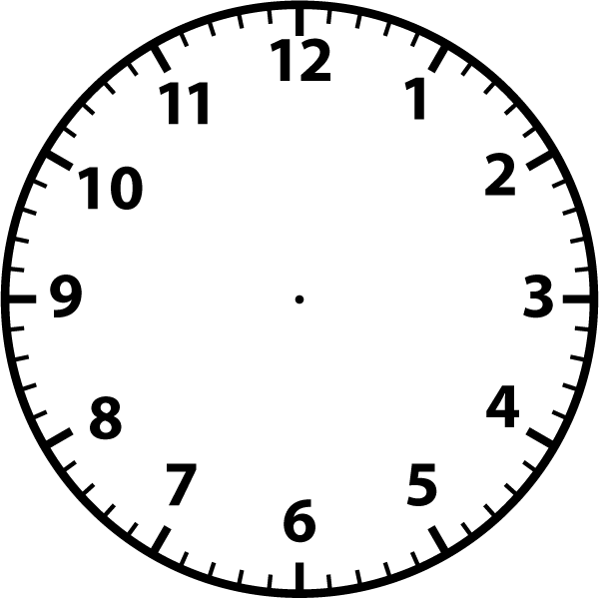  __________________
Tuesday | half of 20 = | 45 | 5 x 3 = | 15 + 8 = | __________________
Wednesday | half of 10 = | 50 | 2 x 6 = | 23 - 7 = | __________________
Thursday | quarter of 12 = | 64 | 10 x 4 = | 14 + 9 = | __________________
Friday | half of 16 = | 72 | 2 x 5 = | 30 - 5 = | __________________
5 A Day

